

PROCESS document

Luzuko Daki st10456445 WEDE5020 POE



Contents

Business Overview 1

Assets 3

Links for images 5

Website Pages / Content 6

# Business Overview

**Business Name:** Sport in TwinsView

**Business Overview:** Sport in TwinsView is a dynamic sports media company founded by sport enthusiast who are passionate about changing the sport media and business industry for the better. Sport in TwinsView is dedicated to delivering comprehensive coverage of a wide array of sporting disciplines, including up-to-the-minute news updates and detailed results. By leveraging the power of social media, Sport in TwinsView releases both short-form and long-form videos that delve into intriguing news and updates of sporting activities from around the globe. We recognize the importance of engaging with our audience across multiple social media platforms, understanding that this approach is vital in reaching and resonating with a global audience.

Sport in TwinsView aspires to make a lasting, positive impact on the sports media industry by contributing to the growth of sports culture. We do this by telling diverse and compelling stories about athletes from all corners of the world, shedding light on their journeys, triumphs, and challenges. Our mission is to become the go-to source for sports coverage, offering a unique blend of timely updates and intriguing commentary that deeply resonates with sports fans. We aim to foster a thriving community of passionate sports enthusiasts, providing them with a space where they can share their love for sports, exchange ideas, and stay connected to the latest developments in the sporting world.

Harnessing the power of social media, Sport in TwinsView meticulously crafts and distributes video content that captures the essence of sports, whether it’s quick updates on breaking news or in-depth analysis of major tournaments and events. Our objective is to produce high-quality content that is not only informative but also entertaining and accessible to a broad audience. By doing so, we ensure that our content caters to the diverse interests of sports fans, while also contributing to the broader discourse in the sports media landscape.

**Products and Services:**

* **Videos:** short and long form videos regarding various sporting codes.
* **Fixtures:** Latest fixtures of sporting events.
* **Results:** Updated results of sporting events.
* **Sport updates:** Updates of various sporting disciplines

**Target Audience:** Sport in TwinsView caters to a diverse customer base including:

* Sport enthusiasts seeking up to date sport news
* Professional athletes interested in video analysis
* Everyday sport fans

**Website Features:**

1. **Homepage:** Links to our social media websites, editor’s pick content, logo and branding.
2. **About Us:** Story of Sport in TwinsView founding, the work behind Sport in TwinsView, and commitment to quality.
3. **Contact Us:** Contact information, email and inquiry form for questions and viewer feedback.
4. **Sport Pages:** Sport pages of various sporting disciplines.
5. **Fan comment pages:** Page for sport fans to talk about any sport event happening anywhere in the world

**Website Theme:** The website should have a primarily black design layout with a dark grey colour palette reflecting the company’s brief and direct atmosphere. High-quality images of sports events should be prominently featured throughout the site to entice sport viewers.

**Key Objectives:**

1. Showcase the company’s quality sport content.
2. Provide accurate information regarding athletes and sport news.
3. Drive sport culture by highlighting sport facts and intriguing international stories.
4. Establish an online presence to attract new subscribers, views, and investors and engage with existing media companies.

**Call to Action:** Sport in Twinview wants to grow the sport media culture in south Africa.

**Conclusion:** Sport in TwinsView is an ideal small business to create a website for, as it offers a wide range of sport content, news update and intriguing stories. By showcasing its sport pages and news online, Sport in TwinsView can attract new subscribers and viewers, drive sport culture, and establish a strong brand presence in the sport community.

# Assets

**Assets**

**LOGO**

HOME image

HOME image

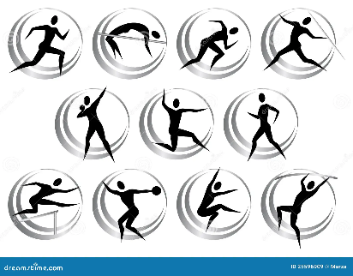HOME image

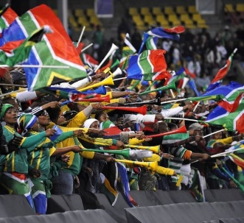will use late

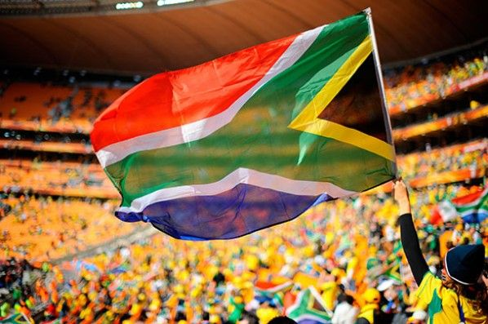will use late

will use late

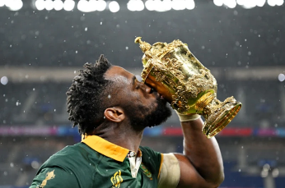**ABOUT US** image

**ABOUT US** image

**ABOUT US** image

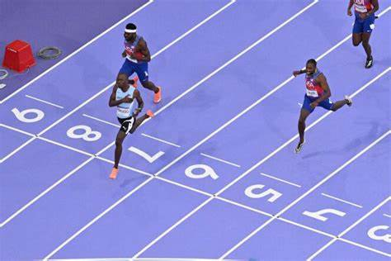**SPORT PAGE** image

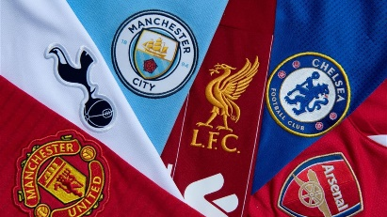 **SPORT PAGE** image

# Links for images

**Links to where I got the images down below**

**Football image link:** [**Soccer Ball vector icon 550705 Vector Art at Vecteezy**](https://www.vecteezy.com/vector-art/550705-soccer-ball-vector-icon)

**Rugby image link:** [**Rugby Ball Graphic by The Crafty Skater · Creative Fabrica**](https://www.creativefabrica.com/product/rugby-ball-3/)

**Athletics image link:** [**Athletics symbols stock vector. Illustration of exercise - 25596909 (dreamstime.com)**](https://www.dreamstime.com/royalty-free-stock-images-athletics-symbols-image25596909)

**SA sports culture:** [**Sports (pinterest.com)**](https://za.pinterest.com/pin/59672763806754525/)

**SA sports culture:** [**Kolisi: “Rugby World Cup victory was for every South African” (pinterest.com)**](https://za.pinterest.com/pin/751327150366506319/)

**SA sport code:** [**Pin page (pinterest.com)**](https://za.pinterest.com/pin/308215168219159251/)

**Different Sporting codes:** [**The Most-Watched Championship Finals in The World (pinterest.com)**](https://za.pinterest.com/pin/1021472759212053514/)

**Kolisi:** [**Kolisi: “Rugby World Cup victory was for every South African” (thesouthafrican.com)**](https://www.thesouthafrican.com/news/kolisi-rugby-world-cup-victory-was-for-every-south-african-31-october-2023/)

**Tebogo:** [**Botswana Celebrates as Letsile Tebogo Returns with Olympic Gold (photonews.com.pk)**](https://photonews.com.pk/botswana-celebrates-as-letsile-tebogo-returns-with-olympic-gold/)

**Messi:** [**Lionel Messi FIFA World Cup Trophy 2022 Winner Wallpaper 4K HD PC #9600h (uhdpaper.com)**](https://www.uhdpaper.com/2023/01/lionel-messi-fifa-world-cup-4k-9600h.html)

**Tebogo/Sport Page:** [**Letsile tebogo 200m france - Search Images (bing.com)**](https://www.bing.com/images/search?q=Letsile+tebogo+200m+france&form=HDRSC4&first=1)

**Prem Teams/Sport page:** [**premier league teams - Search Images (bing.com)**](https://www.bing.com/images/search?view=detailV2&ccid=4hNh30W2&id=9FCDB0D2385B626F3E3701698F4EB93C4F7687FD&thid=OIP.4hNh30W2LXfITGml5M0FFAHaEK&mediaurl=https%3a%2f%2fimgresizer.eurosport.com%2funsafe%2f1200x0%2ffilters%3aformat(jpeg)%3afocal(1366x436%3a1368x434)%2forigin-imgresizer.eurosport.com%2f2020%2f08%2f20%2f2867364-59093288-2560-1440.jpg&cdnurl=https%3a%2f%2fth.bing.com%2fth%2fid%2fR.e21361df45b62d77c84c69a5e4cd0514%3frik%3d%252fYd2Tzy5To9pAQ%26pid%3dImgRaw%26r%3d0&exph=675&expw=1200&q=premier+league+teams&simid=607990679330903511&FORM=IRPRST&ck=D544742245E67F06236D4F3F50166A83&selectedIndex=10&itb=0&ajaxhist=0&ajaxserp=0)

# Website Pages / Content

**Website Pages and Content**

**Home Page:**

**1** Branding

**2** Logo

**3** Links to our other web pages

**4** Content

**5** Links to our social media websites

**6** Images

**About Us Page**

**1** Logo

**2** Links to our other web pages

**4** Content

**5** Images

**Contact Page**

**1** Branding

**2** Logo

**3** Links to our other web pages

**4** Contacts

**Sport Page**

**1** Branding

**2** Logo

**3** Links to our other web pages

**4** Links to our sport channels

**5** Images

**Fan Comment Page**

**1** Branding

**2** Logo

**3** Links to our other web pages

**4** Content

Luzuko Daki st10456445 WEDE5020 POE

**Improvements to part 1**

# I sorted out my word spacing on my Home page from line 31 – 37, About page from line 39 – 41, and contact page from line 32 – 35 Website Pages / Content

**Website Pages and Content**

**Home Page:**

**1** Branding

**2** Logo

**3** Links to our other web pages

**4** Content

**5** Links to our social media websites

**6** Images

**About Us Page**

**1** Logo

**2** Links to our other web pages

**4** Content

**5** Images

**Contact Page**

**1** Branding

**2** Logo

**3** Links to our other web pages

**4** Contacts

**Sport Page**

**1** Branding

**2** Logo

**3** Links to our other web pages

**4** Links to our sport channels

**5** Images

**Fan Comment Page**

**1** Branding

**2** Logo

**3** Links to our other web pages

**4** Content

**CSS PAGE**

**1** Branding colored blue

**2** Logo with boarders

**4** Content

Luzuko Daki st10456445 WEDE5020 POE

**Improvements to part 2**

I sorted out my word spacing on my Home page from line 31 – 37, About page from line 39 – 41, and contact page from line 32 – 35

# Website Pages / Content

**Website Pages and Content**

**Home Page:**

**1** Branding

**2** Logo

**3** Links to our other web pages

**4** Content

**5** Links to our social media websites

**6** Images

**7** Button up

**About Us Page**

**1** Logo

**2** Links to our other web pages

**4** Content

**5** Images

**Contact Page**

**1** Branding

**2** Logo

**3** Links to our other web pages

**4** Contacts

**Sport Page**

**1** Branding

**2** Logo

**3** Links to our other web pages

**4** Links to our sport channels

**5** Images

**Fan Comment Page**

**1** Branding

**2** Logo

**3** Links to our other web pages

**4** Content

**CSS PAGE**

**1** Branding colored blue

**2** Logo with boarders

**4** Content

**Functionality**

I added a Back to Top Buttonthat appears when the user scrolls down, allowing them to return to the top of the page easily.

**SEO**

I implemented good SEO methods throughout my website in order to easily pop up if anyone searches for sport content